pyMatch

Lab # 4

BY

Corey Henry

Cah835

***“On my honor, as a Mississippi State University student, I have neither given nor received unauthorized assistance on this academic work.”***

***Signature X__________________________***

CSE1284 Introduction to Computer Programming

Class Section # 1

Josh Crowson  
Sep 30, 2014

Problem: Develop a game of flipping cards, if they match show the cards, keep track of the score. 2 player game with at least 8 cards, highest score wins

Solution: See attached flowchart**

Sample Execution

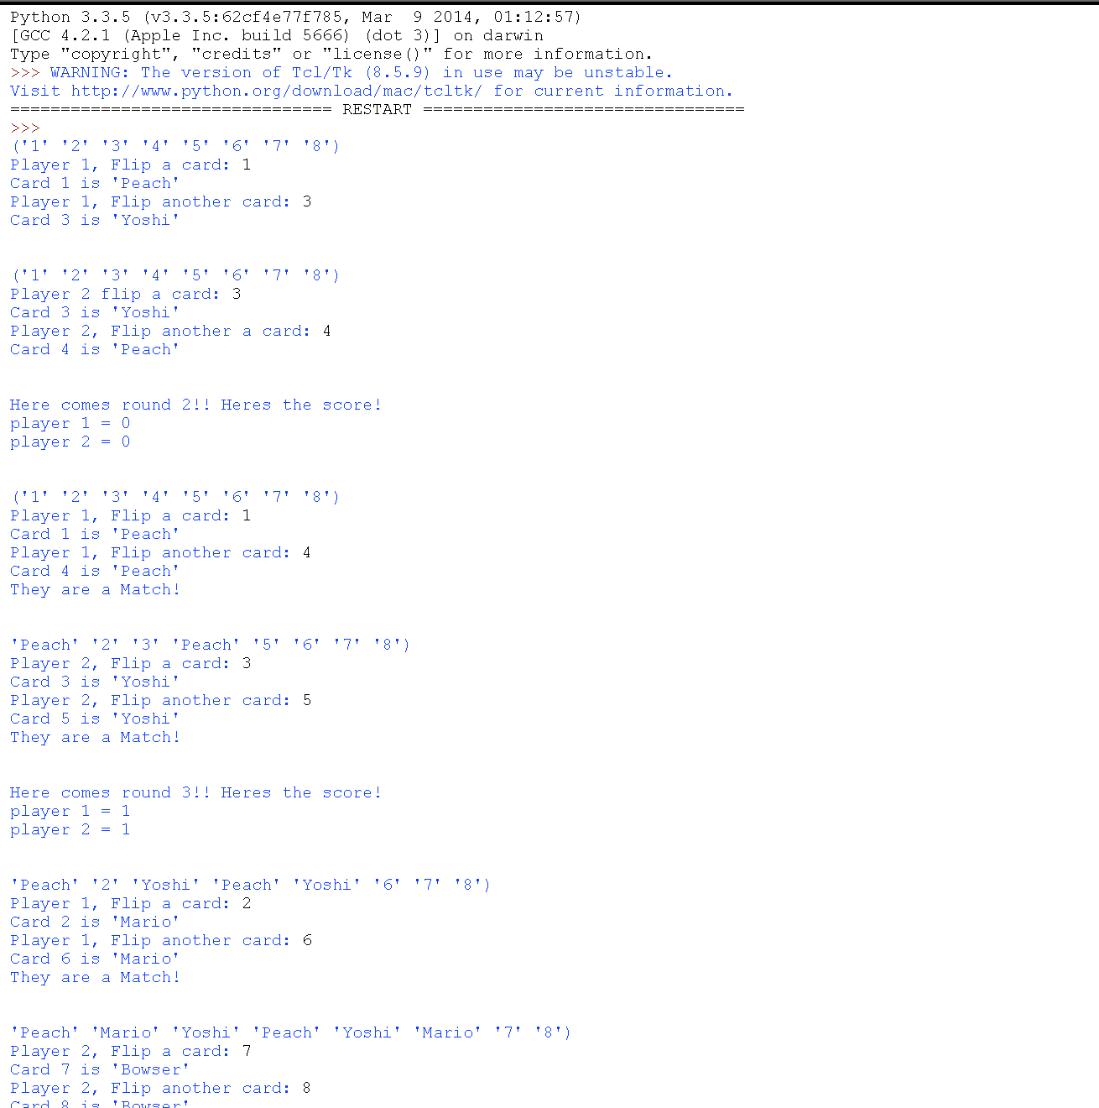

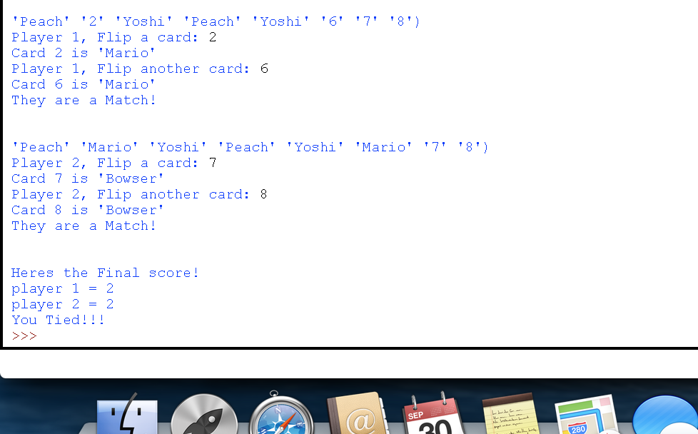

Analysis and conclusion: Lab was medium level difficulty, once I had the format structure done, it wasn’t as hard, really helped figure out how to fine tune my if statements involving math, very challenging as I did the bonus but a very fun lab none the least. Really helped me master IF and ELIF statements.

Code: Submitted via Mycourses.